Lab K

Kiet Le

ID: 218052787

Part 1: Phone the Water Level Sensor

Section 10: Water level at St. Lawrence River at Cornwall

1. Current Depth of the water: 0.55m
2. The date: Nov 24, 2020
3. 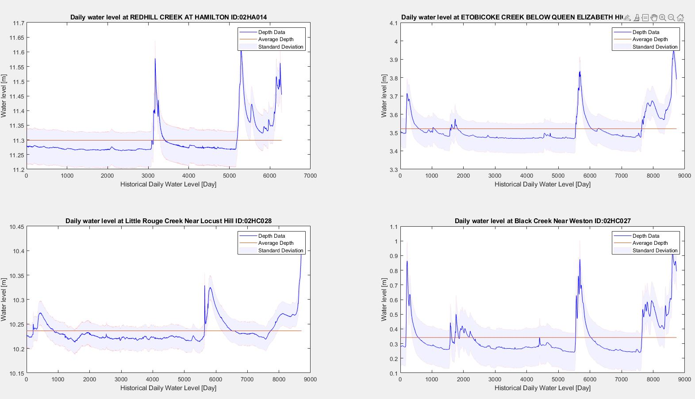The time of day: 12:20PM